SMART MATERIALS APPLICATIONS IN REDESIGNED SYSTEM FOR AIRCRAFT AIR SPEED AND ANGLE OF ATTACK MEASUREMENT
Josip Stepanic jr, Josip Hozmec
Faculty of Mechanical Engineering and Naval Architecture, University of Zagreb
I. Lucica 5, HR-10000 Zagreb, Croatia
T: +385 1 6168 222, F: +385 1 6156 940
Es: josip.j.stepanic@fsb.hr, josip.hozmec@fsb.hr
For required aircraft flight control, beside other pieces of information, a pilot needs several pieces of information related to the aircraft’s velocity. These include the air speed, in its various forms, as well as the angle of attack. Therefore, the complex set of data need to be measured. Usually, it is done by Pitot-static system and the Angle of Attack Sensor. In this article the preliminary research of the possibility of unification of these two devices is given. The unified, alternative design of the sensors relies on smart materials applications. We research here the principal requirements that the alternative proposition of tube design should have, and argue about the possibility for the incorporation of the piezoelectric elements as direct sensor of the aircraft air velocity measuring instrument.
1. Introduction
Instrument for the aircraft speed measurement in the flight direction is required part of the aircrafts’ instrumentation. The instrument’s sensing part is nowadays almost exclusively the Pitot-Prandtl tube [1, 2].
Along with the development of aircrafts’ characteristics and flight requirements additional instruments for measuring the components of suitably parameterised aircraft velocity were installed [2, 3]. Among them, the instrument for measuring the relative angle of the air flow and aircraft air speed, the Angle of Attack Sensor, found particularly important place. The combination of indications of the aircraft air speed indicator and the angle of attack indicator enables a pilot to obtain rather complete information about the instantaneous dynamic of the combined system consisting of the aircraft and the surrounding atmosphere. The underlying complexity of flight control operations, of which the pilot’s registration and processing of the aircraft air speed is only a small part, imposes rigorous requirements on the pilot. Therefore, the possibility of integration of some of the instruments, to be differentiated from the integration of indicators, that are measuring the components of the aircraft velocity relative to air should be considered. The possibility of qualitative change in the set of instruments for aircraft velocity determination would thoroughly change the flight control, so the possible consequences should be evaluated before. From the other point of view, the possibility of installation of the instrument for aircraft velocity measurement would in a part simplify the aircraft’s construction and maintenance. This probability of such a possibility realisation is additionally enhanced with the constant progress in the field of sensors for measurements in fluid mechanics [4].
In this article we are concerned with the very possibility of integration the various components of the aircraft air velocity measuring system, especially aircraft air speed and angle of attack sensor. We formulate the method for quantitative evaluation of the possibility of such an integration and present the results of preliminary research of the subject. We work on the development of method for fluid relative velocity measurements using piezoelectric devices that are directly exposed to the fluid flux.
In the following section we review briefly the present day air speed and angle of attack measuring instrument principles. In the third section we give the piezoelectricity fundamentals, and in the fourth section apply them on the configuration for pressure sensing. There, the response of the piezoelectric device on the time dependent pressure is discussed and the basis for general numerical modelling of such a situation presented. Finally, summary and conclusions are given in the separate section.
2. Instruments for Aircraft Air Speed and Angle of Attack Measurements
Principle of the aircraft’s air speed measurement is the determination of dynamic pressure and its subsequent transformation into data about the relative speed between air and the aircraft [1, 2, 4].
Because of the simplicity of the principle used for this measurement, the duration of tube’s development was a consequence of incorporation of additional requirements, that were imposed by flight conditions. That included the necessity of finding the location of the tube near the aircraft, where the tube functioning would be minimally affected by the fluid velocity field that is formed around the aircraft hull [4, 5]. Usually, this means that the tube is mounted at some distance outside the close vicinity of the aircraft hull, wings or tail. Then the problem of natural frequencies and mechanical stability of the mounting construction arises. In addition, the residual systematic error should depend as least as possible on the changes in parameters describing the flight. Flying in various weather conditions imposed additional requirements on the tube design. For example, a fog or clouds found during the flight may result in the higher concentration of water droplets in the tube and, subsequently, on the finite water volume formed that may preclude the required operational capabilities of the tube. In cases of lower temperatures followed with the overcooled wet atmosphere, that are nowadays regularly realised during a number of flights, an ice layer may form on the tube nose causing again the unwanted changes in the sensor work. In order to keep the predicted operational level, the tube is equipped with the heater. The particular tube is designed to work for the flows with velocity direction that is almost parallel with the tube axis. The angle of deviation between the air flow velocity and Pitot tube axis in the pitch plane is determined using the separate instruments, the angle of attack sensor.

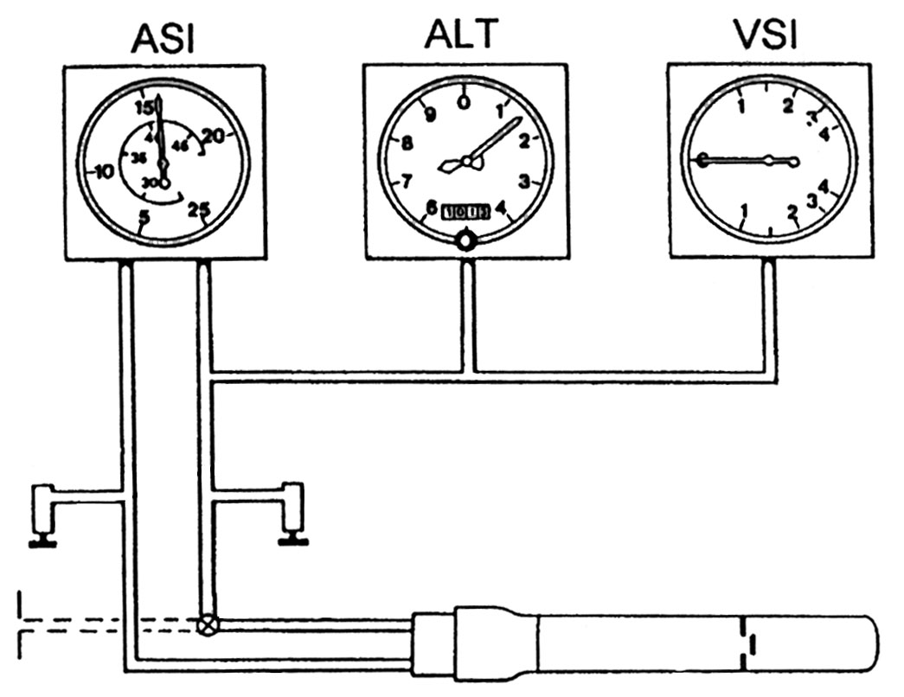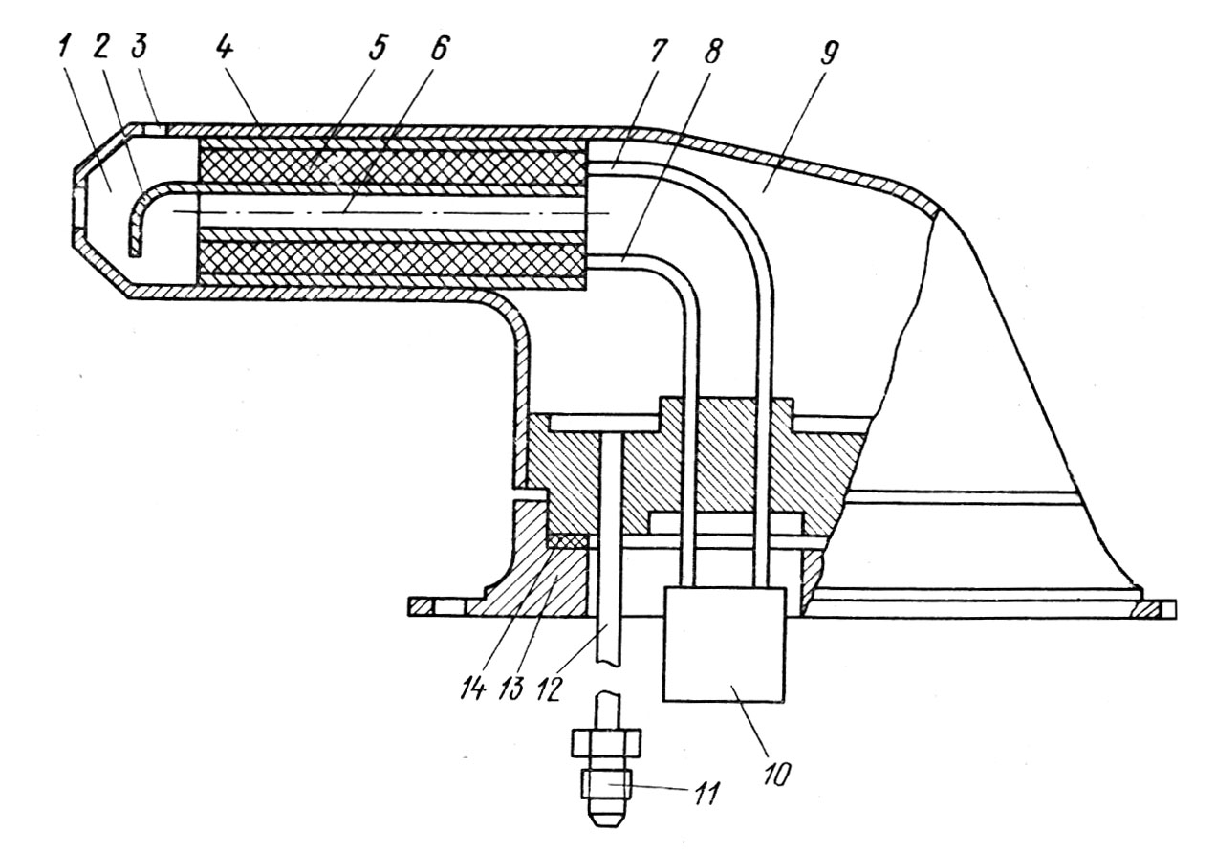
a)
b)
Fig. 1. a) The principal position of the Pitot tube and the aircraft air speed indicator [2], b) the principal scheme of the Pitot tube with different parts 1-14 denoted [1].
The angle of attack sensor, Fig. 2, measures the angle between the part that rotates under the influence of the air flow and the case that is mounted to the aircraft hull.
The two instruments described are separated. Their sensing parts are working using different techniques, while their indicators are put in separate cases.

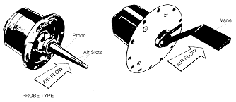
Fig. 2. The angle of attack sensor with sketched working principle [6].
3. Elements of Piezoelectricity for Pressure Sensing
Piezoelectricity is a property of some materials in which the imposing of mechanical disturbance causes a potential difference on the material opposite ends, and conversely. These two manifestations are sometime denoted as the direct and converse piezoelectric effects, respectively [7, 8].
The origin of the effect lies in the specific material’s structure. The examples could be found in natural and in artificial piezoelectric materials. The example of naturally piezoelectric material is quartz crystal. It is characterised by high voltage sensitivity, stiffness comparable to steel. It exhibits the long term stability, does not show pyroelectricity and has relatively low temperature coefficient. The example of artificially piezoelectric material is a polycrystalline ceramic, characterised by high charge sensitivity. In this type of materials one may find materials operating at high temperatures. Generally, these materials are pyroelectric and have temperature induced characteristics variations.
The linear piezoelectric constitutive equations are [7]
$E=β^{s}D−\text{hS}$, $T=c^{D}S−h^{t}D$,
$D=ε^{T}E+\text{dT}$, $S=s^{E}T+d^{t}E$.
Here E and D are vectors of electric field and dielectric displacement vector, respectively, while T and S are stress and strain tensors, respectively. Furthermore, c^{D} is the elasticity tensor at constant D, h and d are the piezoelectric constant matrices, β^{s} is the dielectric impermeability matrix at constant S, s^{E} is the elastic compliance tensor at constant E, ε^{T} is the dielectric tensor at constant T and h^{t} is the transposed tensor h. Because of a simplicity all the tensor fields are written with the indices suppressed. These equations are written with the assumption of balanced mechanical and electric forces in any given time instant, i.e. the quasi-static approximation is used. Piezoelectric sensing elements have essentially no deflection, because of what they are so rugged and have excellent linearity over a wide pressure amplitude range.
In the following section we connect the piezoelectric material response on the fluid pressure applied in a representative geometry.
4. Application of Piezoelectric Materials for Pressure Sensing
In the basic configuration for pressure sensing we consider the piezoelectric material to be set in the substrate, in such a way so that stress applied to one surface does impose reaction only on a connecting surface, the base. The piezoelectric material is put in the interior of the hollow tube through which the fluid flows. This particular geometry serves merely for the beginning. The more appropriate geometry will be analysed later.
However, the very analysis of the fluid flow through the hollow cylinder requires one to simulate the problem numerically, as it is generally nonstationary, tridimensional viscous fluid flow problem [4]. As a consequence to this, one may expect that pressure changes in the tube interior would serve as a reliable basis for determination of the asymptotic fluid flow velocity, i.e. the fluid flow far away from the cylinder. Additionally, because such an element enables the determination of the flow velocity and not just the speed, it could operate as well as the aircraft angle of attack sensor. Therefore, the element described serves as an fluid flow velocity sensor, that provides one with complex data that could be, but need not be, separated into the data about fluid speed and the one about the fluid angle of attack.
There are several reasons why the sensing should operationally be performed using piezoelectric materials. First of all, their response on transient processes is rather fast [7]. This makes them suitable for improved flight control during complex manoeuvres, although may be a drawback as well. As their second suitable property, the piezoelectric crystals may be cut in a variety of ways, differing in the finally shape and dimensions [8]. That makes them suitable for mounting on the described cylinder interior wall, on the positions that are given on the basis of numerical treatment.
Although the described element serves as a basis for a unified air velocity measurement, it is not useful during constant velocity flight, because of the piezoelectric materials’ property of sensing only a transient pressures. However, that could easily be overcome by combining the dynamic part of the Pitot tube with the described element.
By suitable construction, the duration of the transients could be lowered to a value that makes this device a basis for a reliable and fast sensing device for the fluid flow velocity. In order to formulate the possibility for such an element application, the quantitative treatment of the subject should be performed. On the basis of the results obtained, one could determine the conditions in which the described element may serve as a sensor for reliable, and precise air velocity measurement.
5. Conclusions
There are several reasons for working toward a multipurpose aircraft air velocity sensor, i.e. the sensor that could give the data about the aircraft air speed and angle of attack in the same configuration. The preliminary design of such an sensing element is described and ways of numerical estimations of its characteristics formulated. The design is naturally combined with the pressure sensing elements made from piezoelectric materials, because of several characteristics of these that are suitable for the present purpose.
References
- Mihajlov, O. I.; Kozlov, I. M.; Gergelj, F. S.: Aviacionie Pribori, Mašinostroenie, Moskva, 1977.,
- Bucak, T.; Aircraft Instruments (in Croatian), Fakultet Prometnih Znanosti, Zagreb, 1998.,
- Siouris, G. M.: Aerospace Avionics Systems, Academic Press, San Diego, 1993.,
- Figliola, R. S.; Beasley, D. E.: Theory and Design for Mechanical Measurements, John Wiles & Sons, New York, 1991.,
- Gracey, W.; Measurement of static Pressure on Aircraft, NACA Technical Note No. 4184, Washington, 1957.,
- see web page http://www.allstar.fiu.edu/aero/PSSI.htm,
- Rao, S. S.; Sunar, M.: Piezoelectricity and its use in disturbance sensing and control of flexible structures: A survey, Applied Mechanics Review, 47(4), 1994., p. 113-123,
- Oliner, A. A., ed.: Surface Acoustic Waves, Topics in Applied Physics Vol. 24., Springer, Berlin, 1978.

