P. Bezoušek, PhD, University of Pardubice, Czech Republic
V. Kubeček,, PhD , ERA Inc., Pardubice, Czech Republic

accuracy Analysis of A 3D mixed TOA/DOA passive surveillance system VERA
Abstract.
The passive surveillance system VERA serves as a backup air traffic control aid. It consists of three or more terrestrial stations receiving simultaneously signal of an airborne SSR transponder. The emitter position is then usually evaluated using the corresponding Times Of Arrivals (TOA) measurement. In this paper the Direction Of Arrival (DOA) measurement addition to a standard 3D system is analysed and its effect on the aircraft position accuracy is evaluated.

- The 3D VERA system description.
The system under consideration consists of three side receiving stations R, L, Q, a central receiving station C and of a central processing station PS deployed ideally in a triangle according to the Fig.1. The signal, received in the lateral receiving station is retransmitted by a microwave link to the central processing station where the TOA’s of the signals are measured and aircraft position is calculated. Sophisticated SW ensures an automatic tracking of each aircraft and generates an airspace picture and a standard radar report for remote ATC centers. The system is designed to process the SSR transponder replies in A/C and S modes at frequency 1090 MHz or DME interrogation signals.
Fig.1. Basic configuration of a 3D
four position passive system.
d
d
R
L
Q
C
d
Φ
x
PS
The block diagram of the system is shown in the Fig. 2.
Central. process. station
Signal Conditioning
Measur. Unit
Reply Receiver
Micr. Link Transmitter
SIDE receiving station - l
Reply Receiver
Micr. Link receiver
central receiving station -c
Video
TTL
UPS
Communicat.
& Control

FM Modul.

Diagn.
BP Filter
BP Filter
LNA
MIX
IF

LOG
Detectoror
Pulse
Selector

GPS
receiver
Command
Situation Display
Diagnostics
Display

Output Report

PC - II

PC - I

UPS
Target Positioning &Tracking
Micr. Link receiver
Micr. Link receiver
LO
Target Track &Tracking
Fig. 2. Block diagram of the passive surveillance system.

A selection of received pulses on the basis of their pulsewidth is performed after detection. A brodband microwave link is used to transmit the signals to the central station in real time. The modulation of the transmitted signal is performed by mixing the stable local oscillator with another VCO modulated 2-FSK.
At the central station the signals are fed to the measurement unit – a specialised card in the computer PC-I where their TOA´s are measured and respective messages are decoded. Then they are correlated and position of the emitter is evaluated. The GPS receiver delivers the time reference for the whole system. The second computer PC-II generates output reports and data for auxiliary situation display and serves for communication and maintenance.

2. Technical characteristics

The system:
coverage R_{max} = 350 km, azimuth 360°, elevation - full zenith
capacity 300 automatically tracked targets
output data X, Y, altitude, A, C, 1, 2, S address, track quality, update rate 5 sec
The receiving station:
The microwave link:
Frequency band 13 GHz
Modulation FSK, Δf=8 MHz
Antenna φ = 60 cm,
G =35,5 dB
Maximum range 70 km
Receiver sensitivity -95 dBm
at S/N = 25 dB

Noise figure 5 dB
Bandwidth (IF) 14 MHz
Dynamic range 70 dB
IF 70 MHz, logarithmic
Output pulses TTL,
0,45 ± 0,15 μs/3dB,
leading 70 ns, trailing 120 ns

- Position accuracy calculation.
Position calculation is based on a set of equations of the following form:
$\begin{aligned}t_{0}+T_{i}+T_{\text{i0}}+τ_{i}=t_{i} \\ \text{arctg}\left(\frac{y_{0}−y_{i}}{x_{0}−x_{i}}\right)=ϕ _{i} i=1, 2, 3, 4 \\ \text{arctg}\left(\frac{z_{0}−z_{i}}{r_{i}}\right)=ϑ _{i} r_{i}=\sqrt{{\left(x_{0}−x_{i}\right)}^{2}+{\left(y_{0}−y_{i}\right)}^{2}}\end{aligned}$ (1)
TOA measurements
DOA measurements
where: t₀ .... the time of the reply at the aircraft
T_{i} .... the propagation time between aircraft and the i-th receiving station
T_{i0} .... the propagation time between the i-th receiving station and the central station
τ_{i} .... the processing time-delay at the i-th station
t_{i} .... the TOA of the signal primarily received at the i-th station measured at the
central station
x₀, y₀ .... horizontal coordinates of the aircraft
x_{i}, y_{i} .... horizontal coordinates of the i-th station
z₀, z_{i} …. vertical coordinates of the aircraft and the i-th station
ϕ_{i} .... relative azimuth of the aircraft, measured at the i-th station.
ϑ_{i} .... relative elevation of the aircraft, measured at the i-th station.

A standard linearization procedure leads to a set of linear equations for aircraft local coordinates u in the vicinity of the selected point r₀ depending on deviations of measured quantities ΔQ ≡ (Δt_{i}, Δϕ_{i}, Δϑ_{i}) at presence of various errors in TOA and DOA measurement, represented generally by an error vector W: $C\left(r_{0}\right) u+W=\text{ΔQ}$ (2)
where: C(r₀) …. matrix of derivatives of the left-hand side of (1) respective to the aircraft coordinates.
The equation (2) has been studied elsewhere ([1], [2]). In [2] we discussed the effects of long term variations and systematic errors on the system accuracy. Recently a complex system using mixed TOA and DOA measurement was suggested for aircraft position calculation and signal separation [3]. In the present paper we concentrate on short term fluctuations and particularly on possibility of 3D system measurement accuracy enhancement by adding direction of arrival measurements. The standard deviations of TOA measurement in the VERA system due to short term fluctuations is estimated equally to Δt = 10 ns in all channels ([2]). The standard deviations of DOA measurement depend on antennas dimensions and S/N ratios. Here we assume that all four stations produce equal standard deviations of azimuth Δϕ and elevation Δϑ measurement.
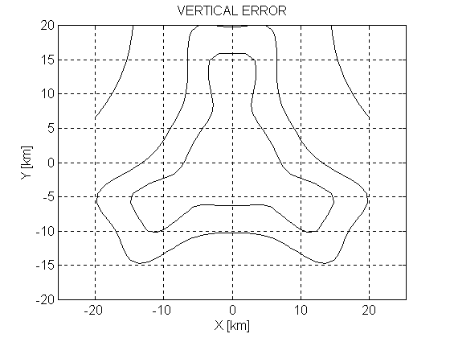
As an example of computed results we may see in the Fig. 3 the vertical position accuracy in a constant altitude h = 2 km, with the central to side station distances d = 8 km with only TOA measurement. Comparable results have been achieved during the fly test, carried out at Pardubice under the management of EUROCONTROL (Fig. 4). The aircraft altitude was measured with accuracy of 65 ft (RMS) along direct parts of its trajectory.
25 m
50 m
σ_{v}= 150
m
Fig.3. Vertical rms errors of a pure TOA based system. d = 8 km, h = 2 km, Δt = 10 ns.

The comparison of a real TOA-measurement-based system and a hypothetical mixed TOA/DOA-measurement system is shown at the Fig. 5. We may see that adding only azimuth measurement has a small effect on the observed parameters except of in the case of a very good angle-resolution antenna (Δϕ = 0.1°). The same is true for both the horizontal and vertical position accuracy. But adding elevation measurement substantially enhance the accuracy even in the case of a low resolution antenna (Δϕ = 1°) which would be obtained with reasonably small antennas. The plausible effect of elevation measurement on accuracy is more pronounced than that of the azimuth measurement (namely at the longer range) obviously due to relatively low aperture in a vertical plane of the pure TOA based system for low altitude targets.

4. Conclusions.
The passive system VERA is an application of a multisensor data fusion processing and represents a principally new, high performance and relatively simple and low cost multifunction device. The system is produced at ERA Inc. Pardubice in several versions, designed for various applications as an ATC surveillance aid, an airport surface movement control tool, an independent height measuring equipment or as a passive air defence system. The same concept is a hot candidate as a ground based backup of an Automatic Dependent System - Broadcast after 2010 and is now intensively examined in USA and Europe as well. Nevertheless further enhancement of the system accuracy is permanently actual. In this paper we examined the effect of adding the direction of arrival measurement in azimuth and elevation planes. We find out that this could be particularly useful in the case of short based systems and preferably when DOA measurement in the elevation plane is performed.

References
[1] Koenke E. J., Geyer M., Lay R., Vilcans J.: Beacon Multilateration System to Facilitate ADS-B, The 53rd ION Conference Proceedings, Albuquerque, June 30 - July 2, 1997
[2] Bezoušek P., Kubeček V., Štěrba P.: A Passive Radar Surveillance System VERA for ATC, Proc. of the IRS99 Conference, Vol I, Munich 1998, pp. 39 – 48
[3] Petrochilos N., van Genderen P.: A New Approach to Handle the Secondary Surveillance Radar Replies, Int. Conference on Radars, Brest, France, May 1999
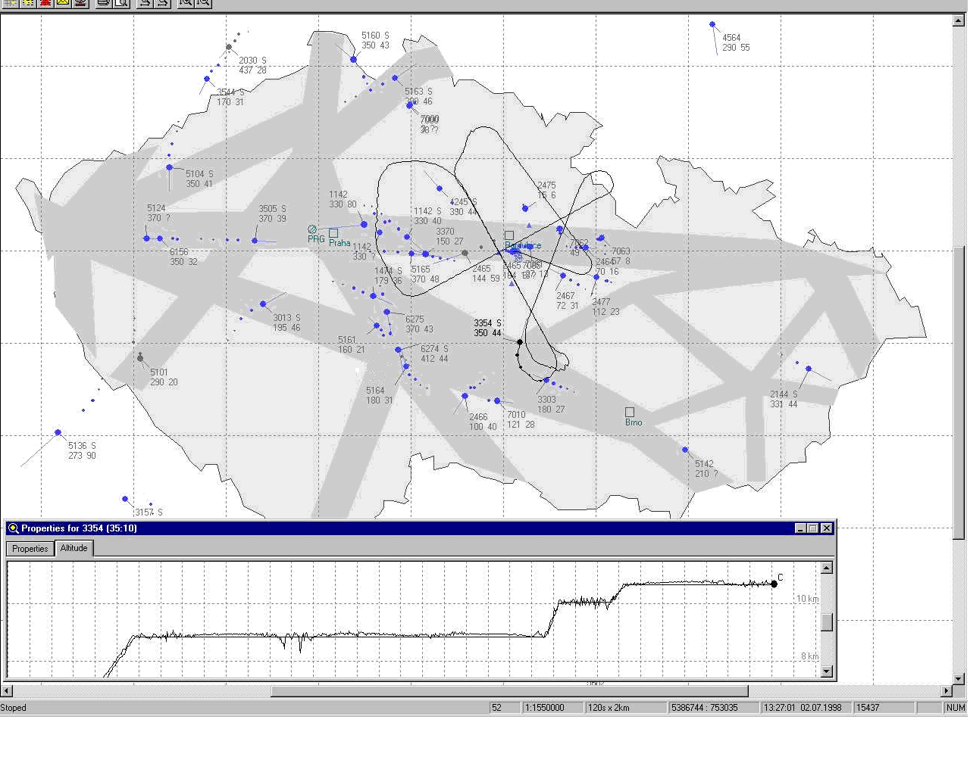
Fig. 4. A fly test at Pardubice, base distance of the passive system d = 8 km. The measured altitude profile in comparison with the mode C replies record (the smooth curve) is in the lower window.

Pardubice
Test aircraft trajectory

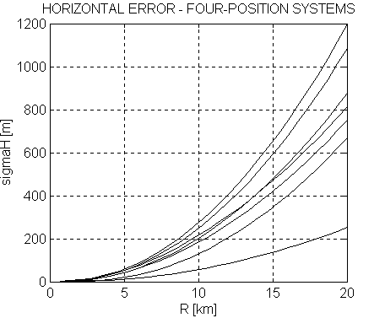
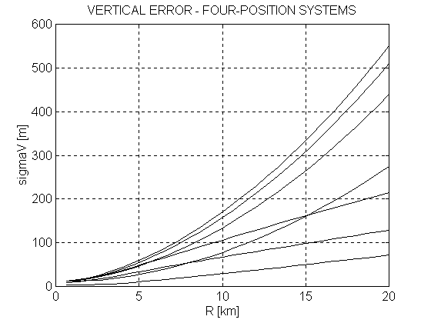
1
1
2
2
3
3
4
4
5
5
6
6
7
7
Fig. 5. Position errors in mixed TOA/DOA measurement system. d = 2km, h = 2 km, azimuth cut Φ=30°. 1…. TOA only Δt = 10 ns , 2 …. TOA+ azimuth Δϕ = 1°, 3 …. TOA+ azimuth Δϕ = 0.5°, 4 …. TOA+ azimuth Δϕ = 0.1°, 5 …. TOA + elev. Δϑ = 1°, 6 …. TOA+ elev. Δϑ = 0.5°, 7 …. TOA+ elev. Δϑ = 0.1°

